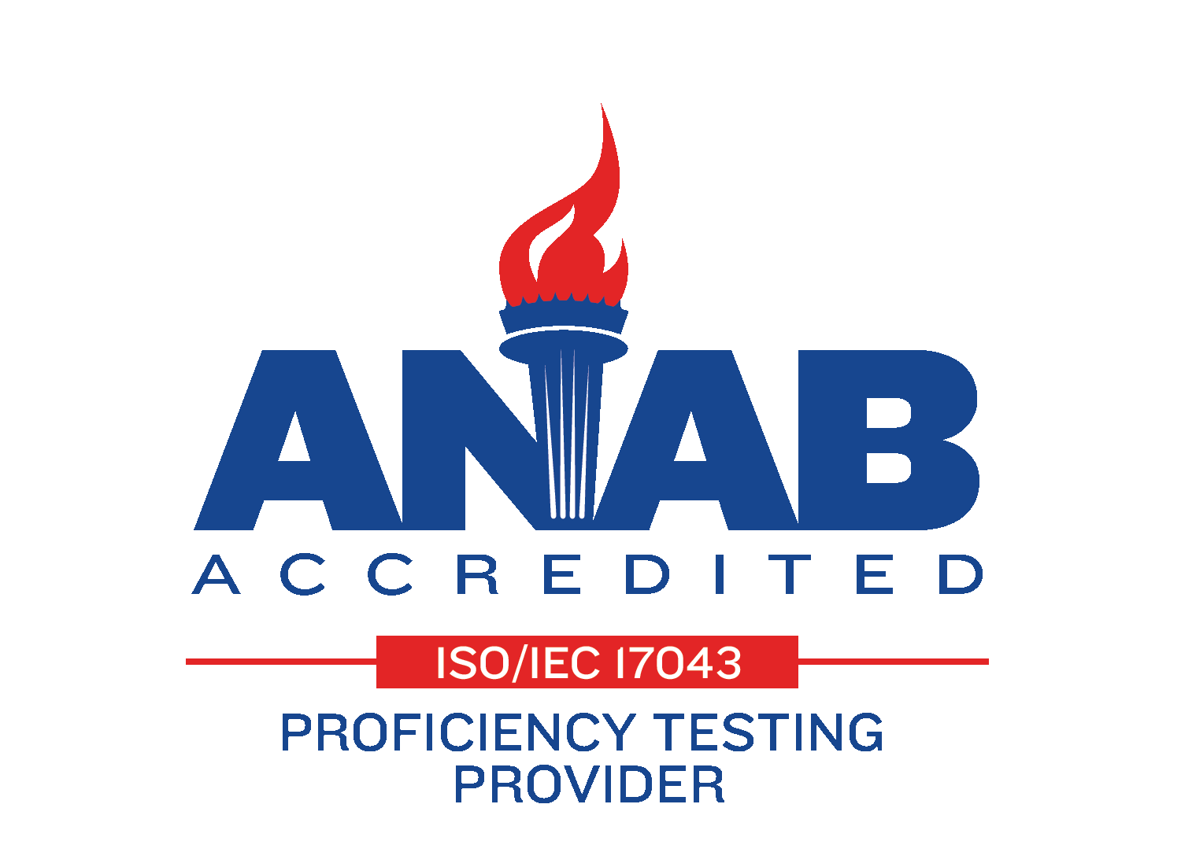
2023 Cross Check Program Schedule-Now shipping internationally, where possible
If you would like to participate in our ISO 17043:2010 accredited proficiency test, ‘PT’, program for 2022, please email our customer service department at isotrakusa@ezag.com or contact us at 1-404-352-8677 at your earliest convenience and we will prepare a quotation. If you would like to receive the same products and delivery schedule as your current samples, please include this information in your email as well. To ensure your 2023 samples ship on the standard schedule below, please submit your purchase order no later than 7 weeks in advance of the ship date except as noted below.
For 1st quarter participants, we need your PO no later than January 3rd to ensure shipment the week of February 10th.
Radiochemistry Cross Checks (HCC)
1st quarter- Ships the week ending February 10th
2nd quarter- Ships the week ending May 12th
3rd quarter- Ships the week ending August 11th
4th quarter- Ships the week ending November 3rd

For 1st quarter ECC cross check samples, please have the PO submitted by January 23rd to ensure shipment the week of March 16th.
Environmental Cross Checks (ECC)
1st quarter- Ships the week of March 16th
2nd quarter- Ships the week of June 15th
3rd quarter- Ships the week of September 14th
4th quarter- Ships the week of November 30th

